Lecture -298 AWS DynamoDB - Review of NoSQL and Data Types

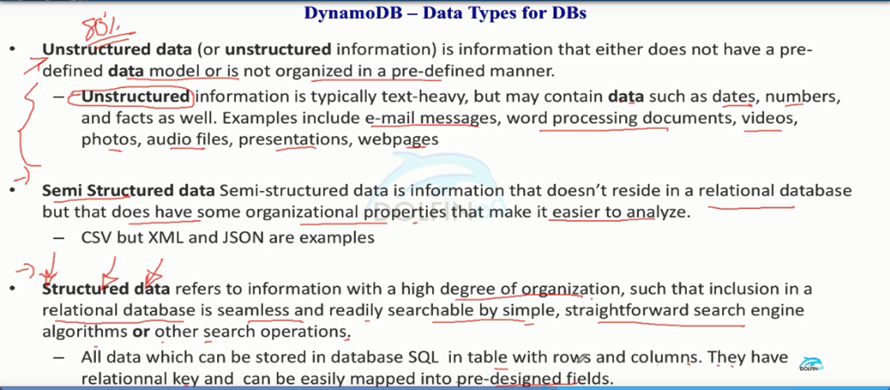

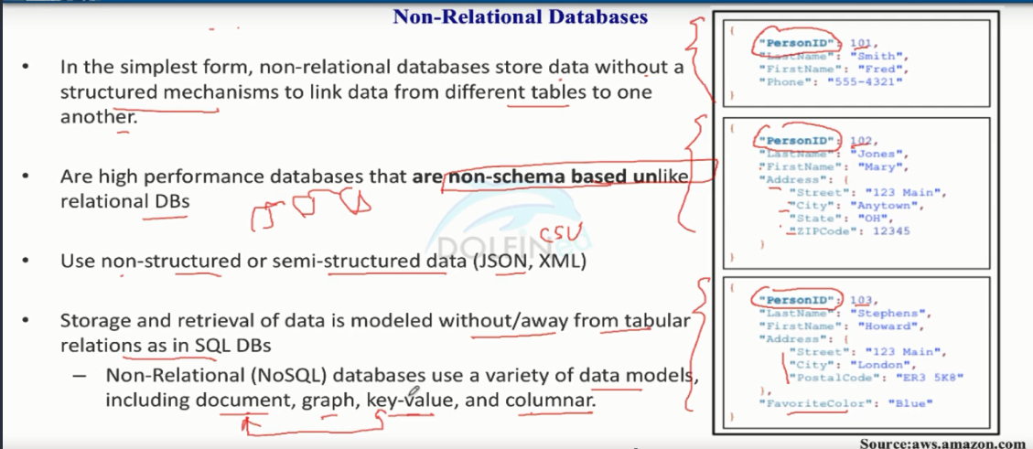

Lecture -299 DynamoDB Introduction

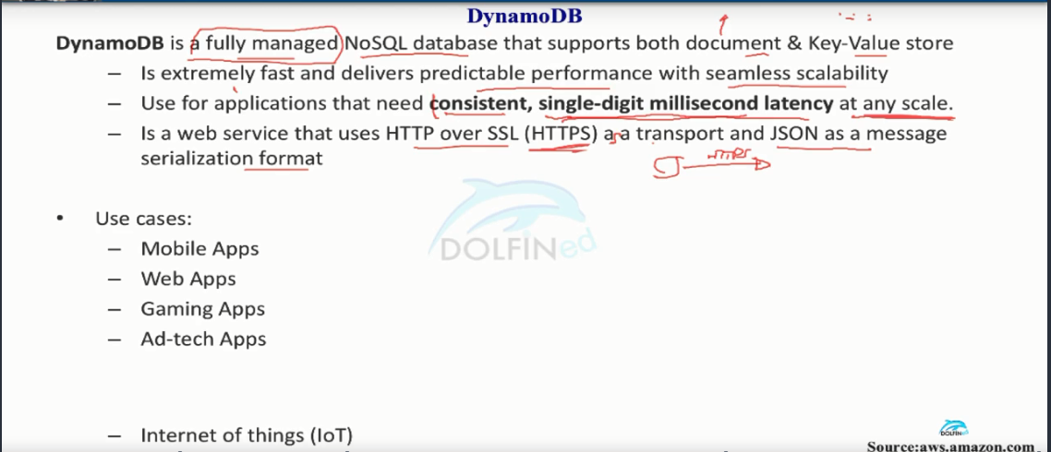

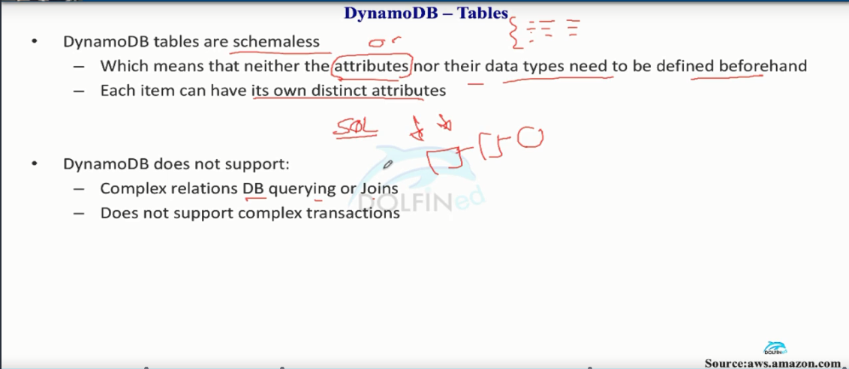

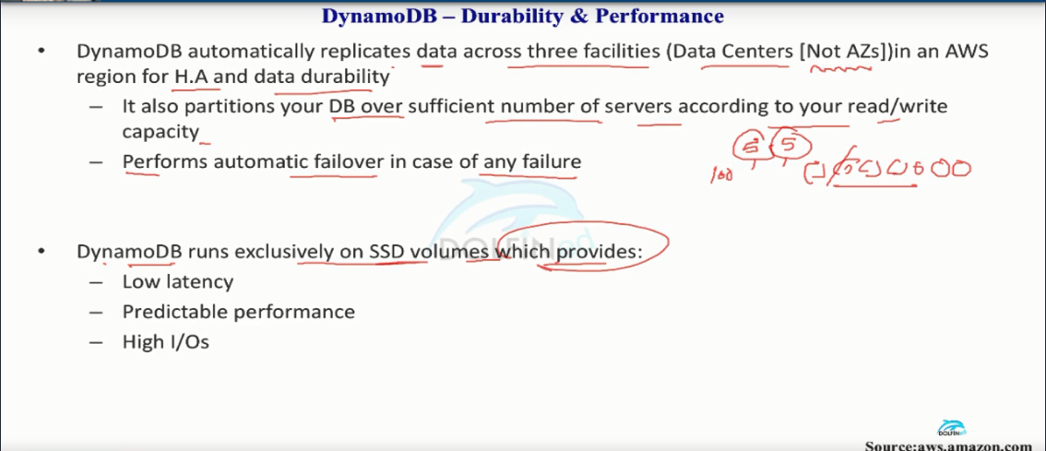

For the 1st in the above pic , Dynamodb also provides a facility called global writes with which you can set up for EX: Create a table in region 1 & another table in region 2 and it will replicate when ever you write the data to a table in one region to other region. (PS: check internet to get more clarity)

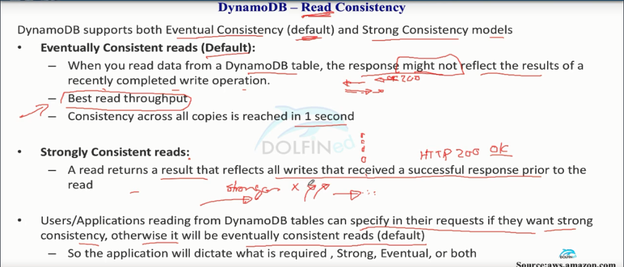

Lecture -300 DynamoDB tables, components, Primary Key

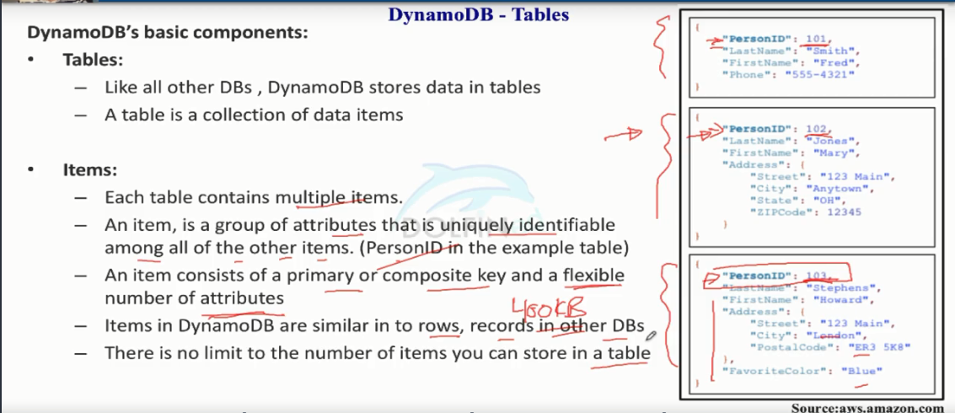

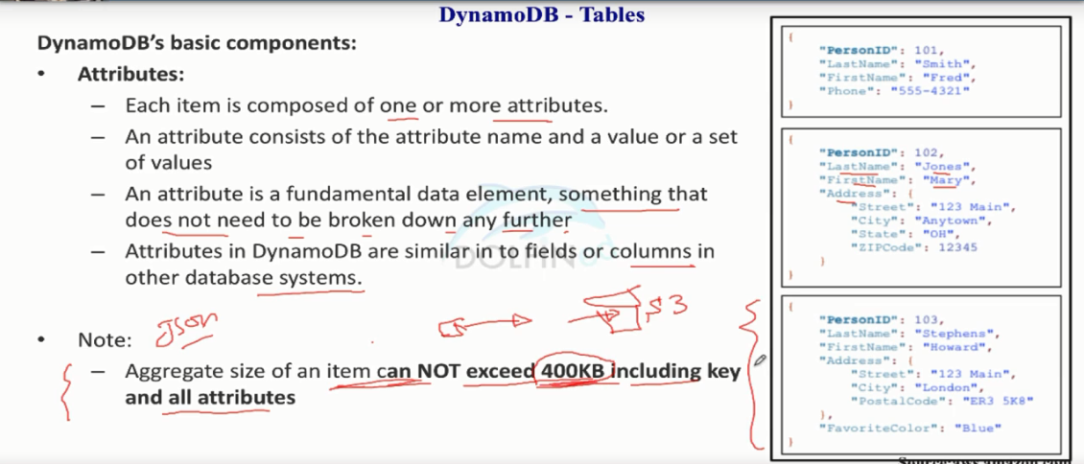

If you have an item more than 400KB then you can store it in S3 bucket and provide a pointer to s3 in the table

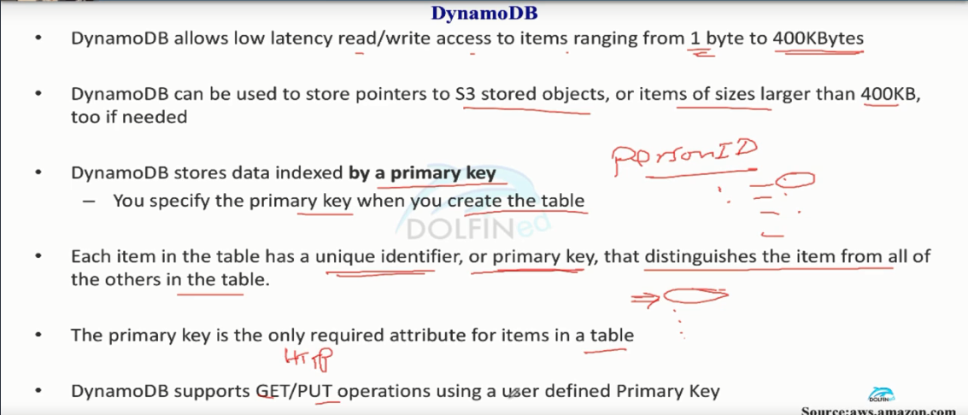

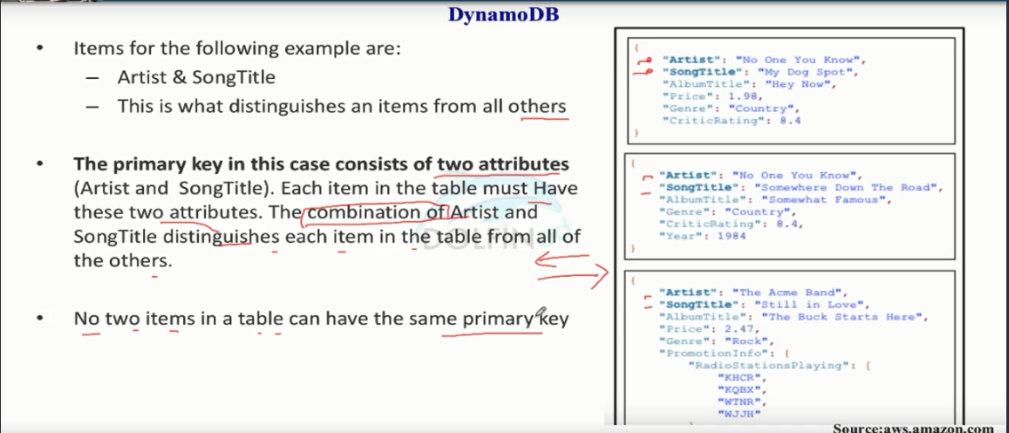

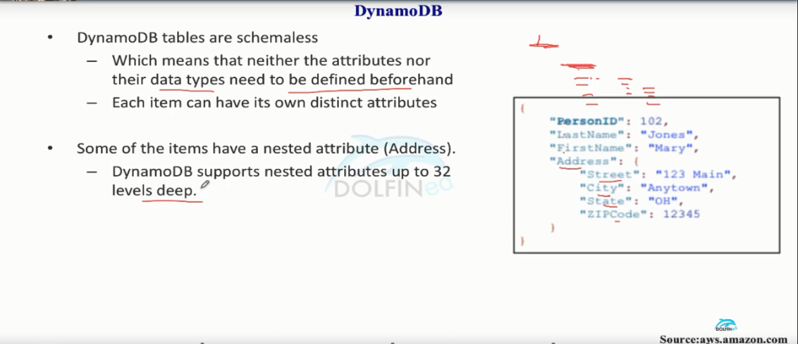

Lecture- 301 DynamoDB Table Throughput

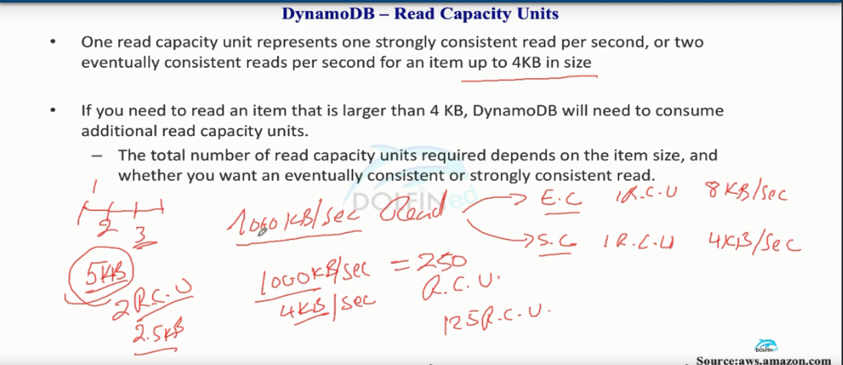

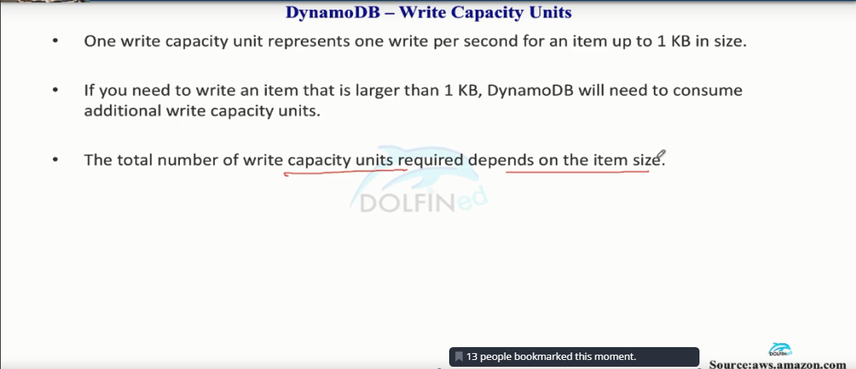

From the above 2 pics we can say that if an application have more read capacity units (rcu) than write capacity units(wcu) DynamoDB would be the cost effective solution.

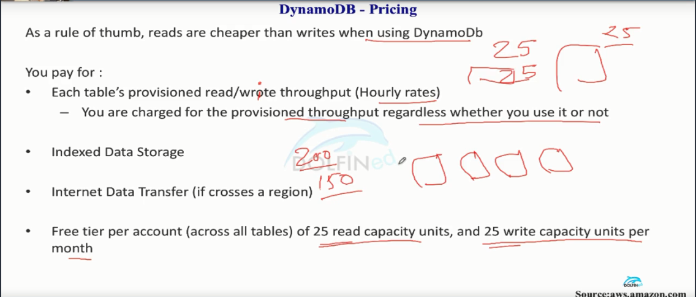

Lecture – 302  DynamoDB Scalability, Throttling, and Limits

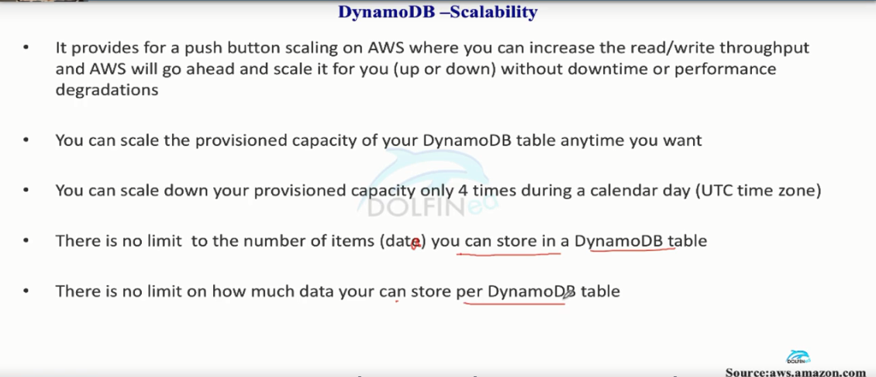

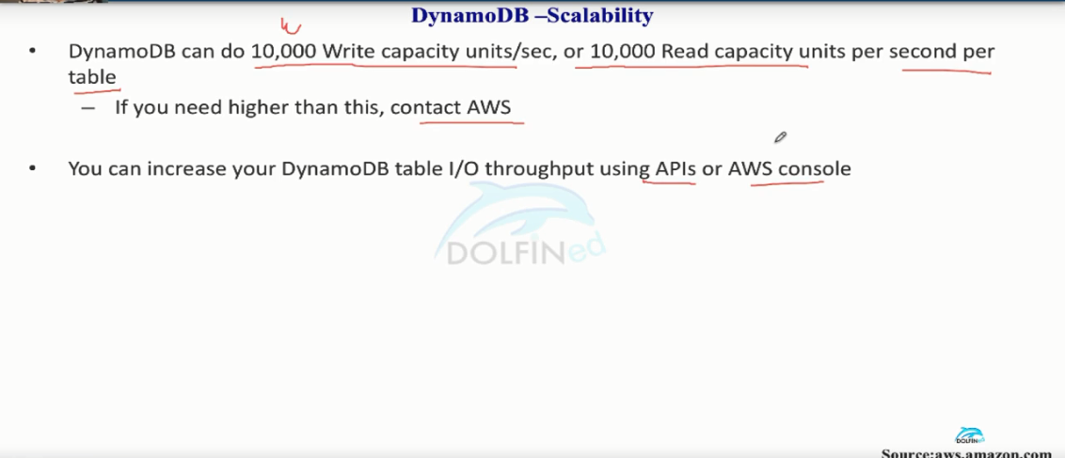

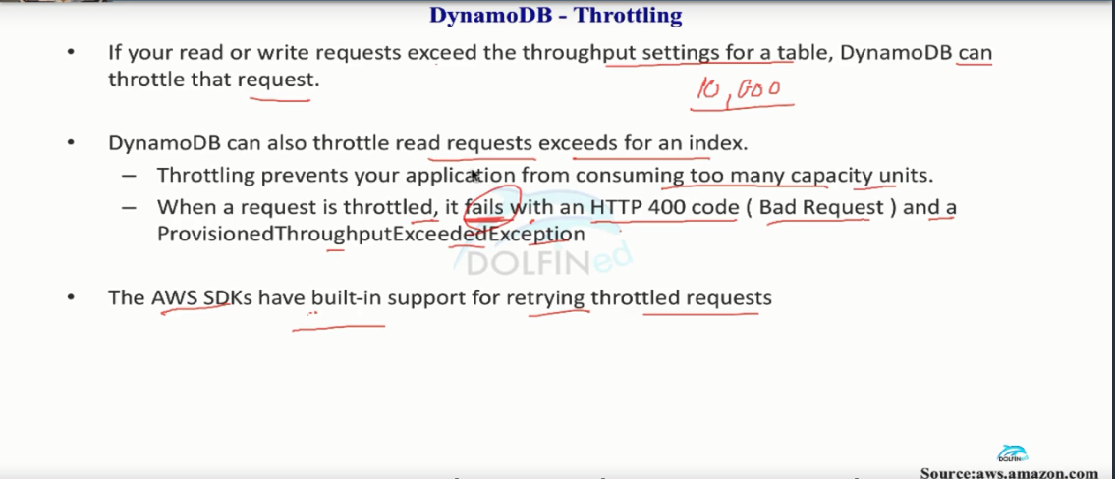

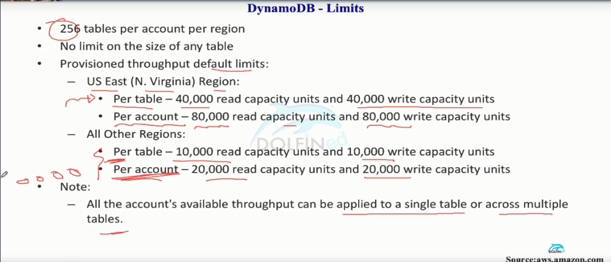

Lecture -303 DynamoDB integration with RedShift and AWS EMR plus Best Practices

